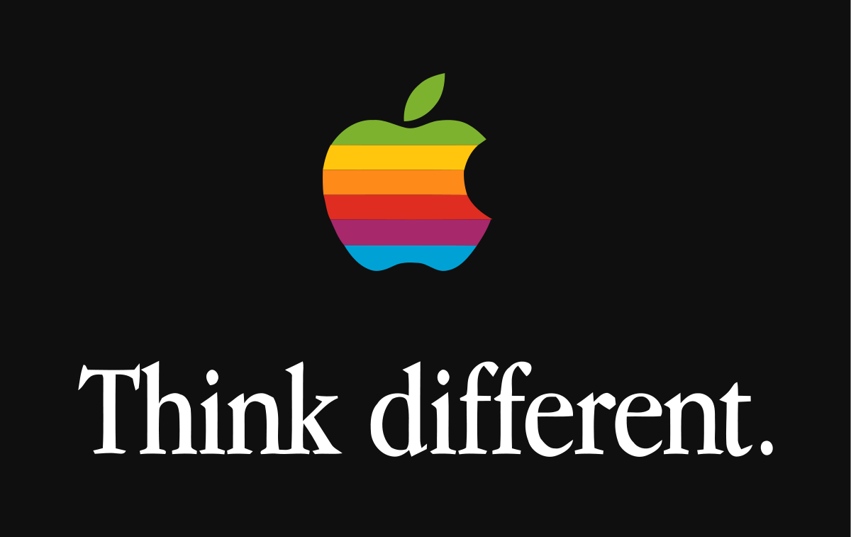

Facts don’t matter.
You read that right. Nobody is swayed by facts. It may be factually correct that you have the biggest law firm by headcount in your city, but consumers don’t care. Consumers place little reliance on facts, and as a persuasive tool, facts are weak.
It’s factually true that fast food is not good for you. Everyone knows that. It’s an undeniable fact.
But did you ever walk past McDonalds restaurants on weekends?

Just Do It.

BY COMMON AGREEMENT Nike have made some of the greatest adverts of all time.

They achieved this by changing strategy. Instead of trying to convince consumers that their trainers or sports gear were better than Adidas or Reebok they focused on something else the “customer experience”.

What should Nike customers feel if they bought a Nike product?
Nike sponsored elite athletes like Michael Jordan, Tiger Woods and Ronaldinho. Their “Just Do It” ads have redefined sports culture like no other brand.

Nike is now considered more than just a sports company. It has developed a brand which is synonymous with elite athletes. By linking itself to elite athletes Nike became -by extension- an elite brand.

And they achieved this by refusing to waste huge sums trying to convince customers that their running shoes were better than the competitions.

Think Different

When he returned to Apple in 1997 the company was, according to Steve Jobs, “about ninety days from going bankrupt”. Today it is the most valuable tech company on earth. Jobs pointed to Nike’s advertising success (“one of the greatest jobs of marketing that the universe has ever seen”) as the template to be followed.

Apple followed that template.

They gave up trying to convince consumers that Apple’s products were better than Microsoft’s or Dell’s because of superior “speeds and feeds…MIPS and megahertz”.
Jobs realised that customers didn’t care. They wanted more than that. They wanted to know what Apple stood for and where Apple “fit in this world”. Customers wanted to know what Apple, at its core, stood for.

Jobs set out to answer this. He decided that Apple’s core value was that people with passion could change the world for the better.

That was it.

Apple then ran a new advertising campaign. Called “Think Different” the campaign didn’t talk about new and exciting Apple products; instead, it celebrated people whose work advanced the human race: Picasso, Amelia Earhart, Gandhi, Martin Luther King, Einstein etc.

Here was an ad by a computer company that didn’t feature a single product.

By linking their brand to such titans’ customers began to get a sense of what Apple aspired to: excellence.

That’s Apple’s brand.

Is the iPhone the best value for money in smartphones?
No.
Is its technology the most advanced?
No.
What about it’s battery life?
Hardly.

But these things don’t matter to customers.
What matters is the feeling you get when you buy an iPhone, when you unbox it (the packaging of Apple products are specifically designed to create a feeling of ‘quality’ as soon as you touch the white box) and hold it.

Remember, Apple never tells you that it’s products are better than their competitors, but no other technology company comes even close to competing.

